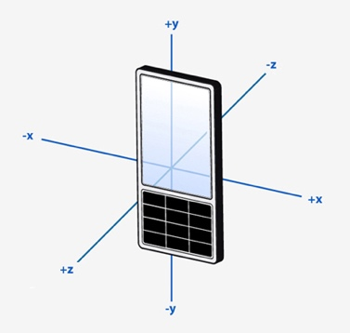
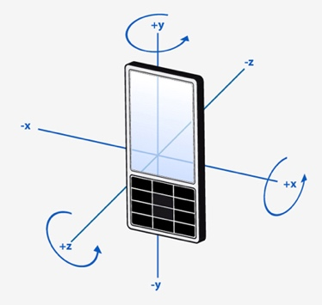
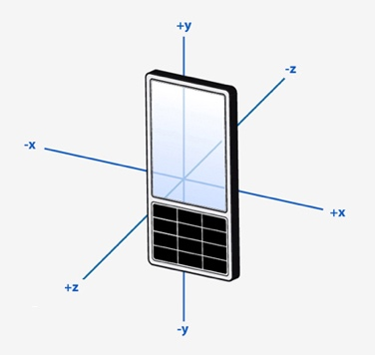
Accelerometer GYRO MAGNETOMETER

Z + x = Pitch Y = Pitch Z +x = Pitch
Y + x = Roll Z = Roll Y + x = Roll
X = Yaw X = Yaw Y + z = Yaw

